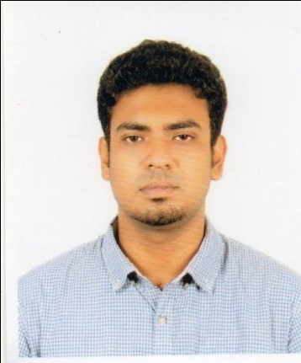

|  |
| --- |
| Kazi Musfiqur Rahman    Dhanmondi, Dhaka- 1205  Mobile no: 01711668687 Email: kmusfiqe@gmail.com |

**KEY QUALITIES**

To make life challenging through a creative and competitive where I have the opportunity to assert strong sense of responsibility to know about the real world laid ahead of me.

**EDUCATION QUALIFICATIONS**

**Program:** Masters

**Department:** Geography & Environment

**Name of the institution:** Dhaka University

**Year of Passing:** 2018-2020 (Continuing)

Program: BBA

**Department:** Business Administration

Name of the institution: University of Asia Pacific

Year of Passing: 2013-2017

CGPA: 3.18

Program: HSC **(**Higher Secondary Certificate**)**

**GPA:** 3.2 out of 5

**Group:** Science

**Institution:** GOVT. Laboratory School & College

Year of Passing: 2013

**Board:** Dhaka

Program: SSC (Secondary School Certificate)

GPA: 4. 63 out of 5

**Group:** Science

**Institution:**  Satkhira Govt. High School

Year of Passing: 2011

**Board:** Jessore

**Extra Curricular Activities**

Vice President and volunteer at Ingenious Marketing Club at UAP (2017)

Organized Rag Program at UAP (2017)

Participated Health Awareness Program Organized by Madtronic Company (2017)

Treasurer and volunteer at School of Business Cultural Club at UAP (2014)

**Achievements**

Presented research paper at 13th Asian Business Research Conference (2015)

Participated in Ad Blitz Competition (2017)

**Computer Literacy**

Windows Office Package (MS Word, M.S Office, MS Excel, MS Power Point, M.S Access. )

**Personal Details**

|  |  |  |
| --- | --- | --- |
| Father’s Name: |  | Kazi Mizanur Rahman |
| Mother’s Name: |  | Kazi Banani Rahman |
| Date of Birth: |  | 10 January, 1996 |
| Blood Group: |  | AB+ |
| Interest and hobbies: |  | Listening to music, playing cricket, reading newspaper and Traveling. |

**Reference**

Shamsad Ahmed

M.Pharm (DU), MBA (IBA, DU), Department of Business Administration

University of Asia Pacific

Thanking with your best regards,

Kazi Musfiqur Rahman